How to Consolidate HL7 Ballot Comment Spreadsheets

The purpose of this process is to consolidate all BRIDG ballot comment spreadsheets and all web-based comments into one master comment spreadsheet. This consolidated spreadsheet makes it much easier to manage the ballot reconciliation process since all the comments are in place.

Note: Ballot commenters can either fill out a spreadsheet with their comments or submit them using a web-based interface. Most commenters use the spreadsheet, but it seems that there is always one person that uses the web-based interface.

1. Create a folder on your computer to contain all the files that you will be downloading from the HL7 website for this process.
2. Login to Smita’s HL7 account or another member’s account on www.hl7.org.
   1. username = smita.hastak; password = 22024; ask Smita if this doesn’t work. It could have changed. It works as of 27 June 2019.
3. Go to the ballot desktop by selecting Ballot Desktop under Quick Links on the right-hand side of the HL7 Home Page.

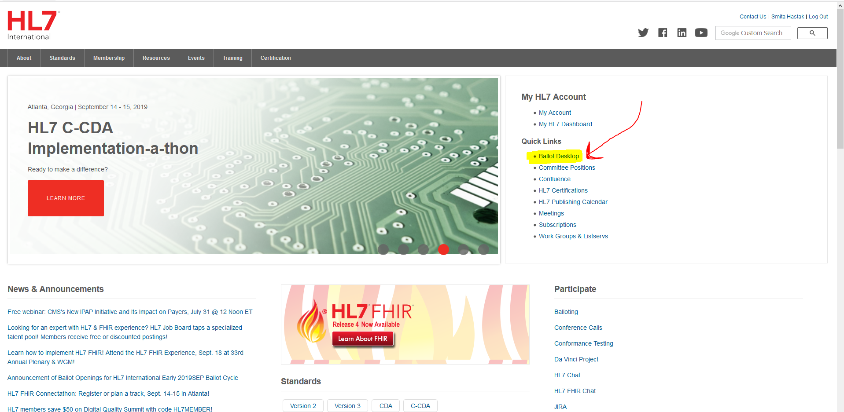

1. Download all the comment spreadsheet files that need to be consolidated into one master spreadsheet of comments.
   1. Click on the “Tally” tab at the top of the Ballot Desktop.
   2. Download the zip file with all the ballot results in it. Save it to the folder you created in step 1.

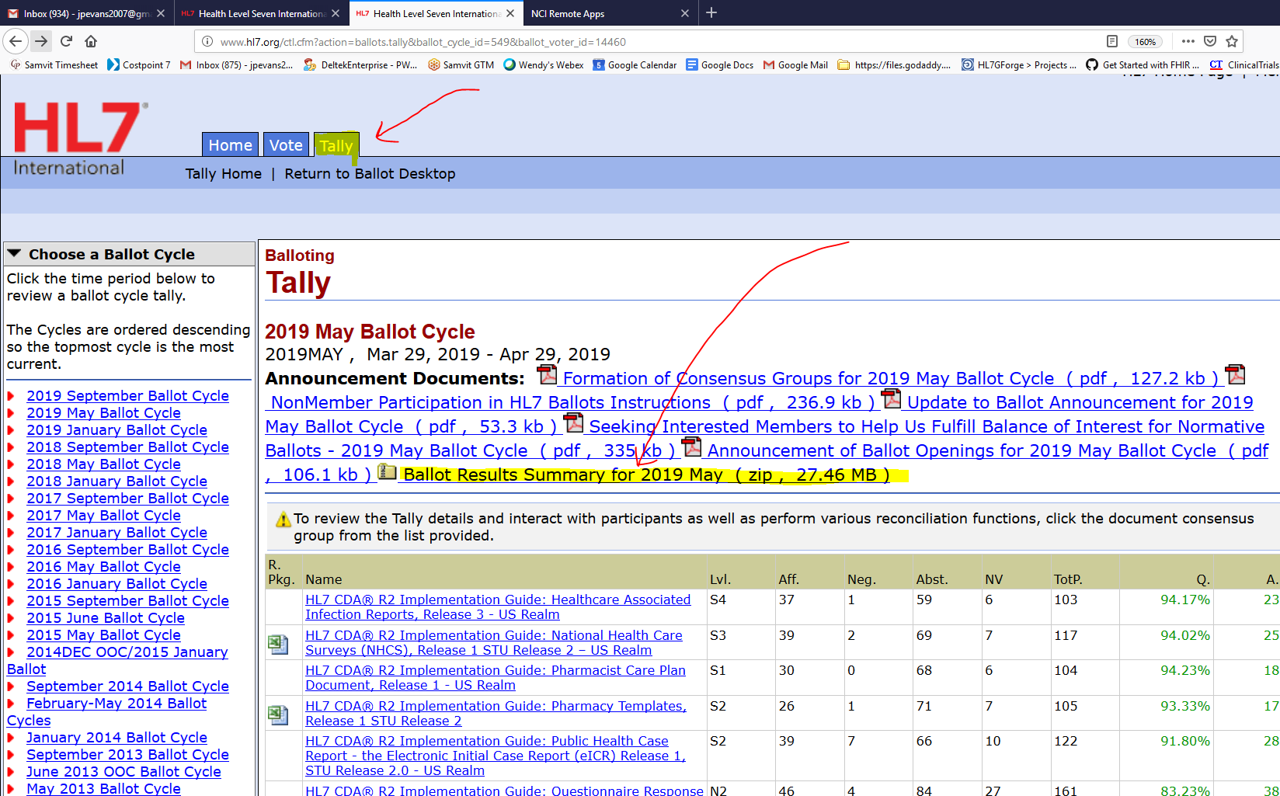

* 1. Unzip the Ballot Results Summary file and find the BRIDG ballot results.

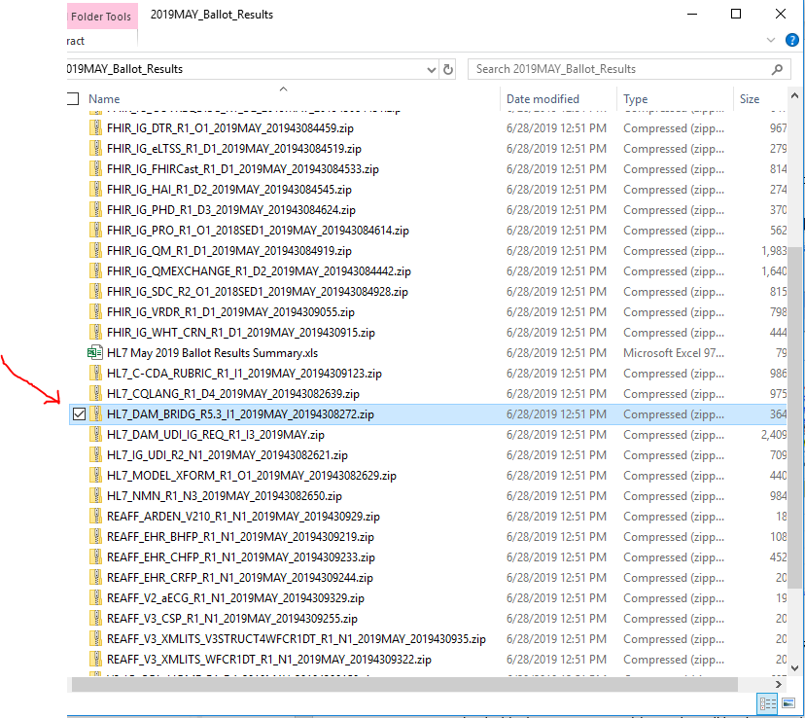

* 1. Unzip the BRIDG Ballot Results zip file that you just found in the previous step. It should contain a number of files and look something like this in Windows Explorer:

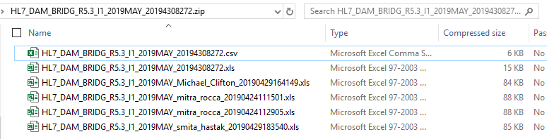

Notes:

* The csv file contains all the comments that came from the web-based interface.
* The xls file which doesn’t include participant names in the filename is the voting detail for each participant (name, organization, vote, etc.).
* The xls files which include participant names in the filename contain the comments from participants that submitted their comments via a spreadsheet that they uploaded to the ballot desktop.

1. Download a blank comment spreadsheet. This is spreadsheet that will contain all the consolidated comments.
   1. The blank comment spreadsheet zip file contains the blank comment spreadsheets for all ballots, so you will need to find the BRIDG comment spreadsheet in the large list and use that one.
   2. Save this file in the folder that you created in step 1.

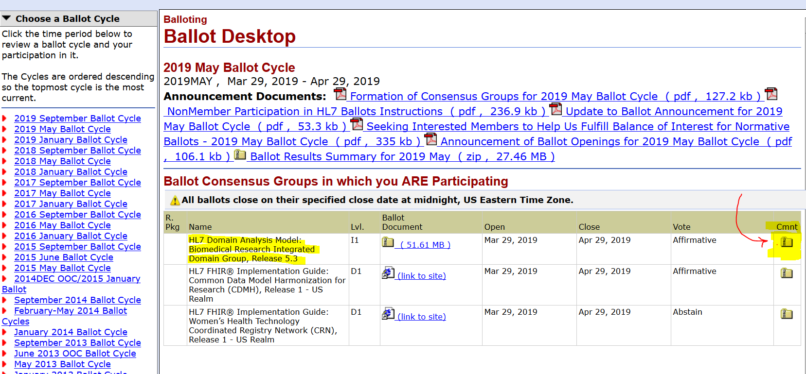

1. Download the Ballot Amalgamation Macro Worksheet zip file.
   1. Scroll down to the bottom of the Ballot Desktop page, look down to the lower left of the window, and download the file.
   2. Move the zip file to your amalgamation folder, then unzip it.

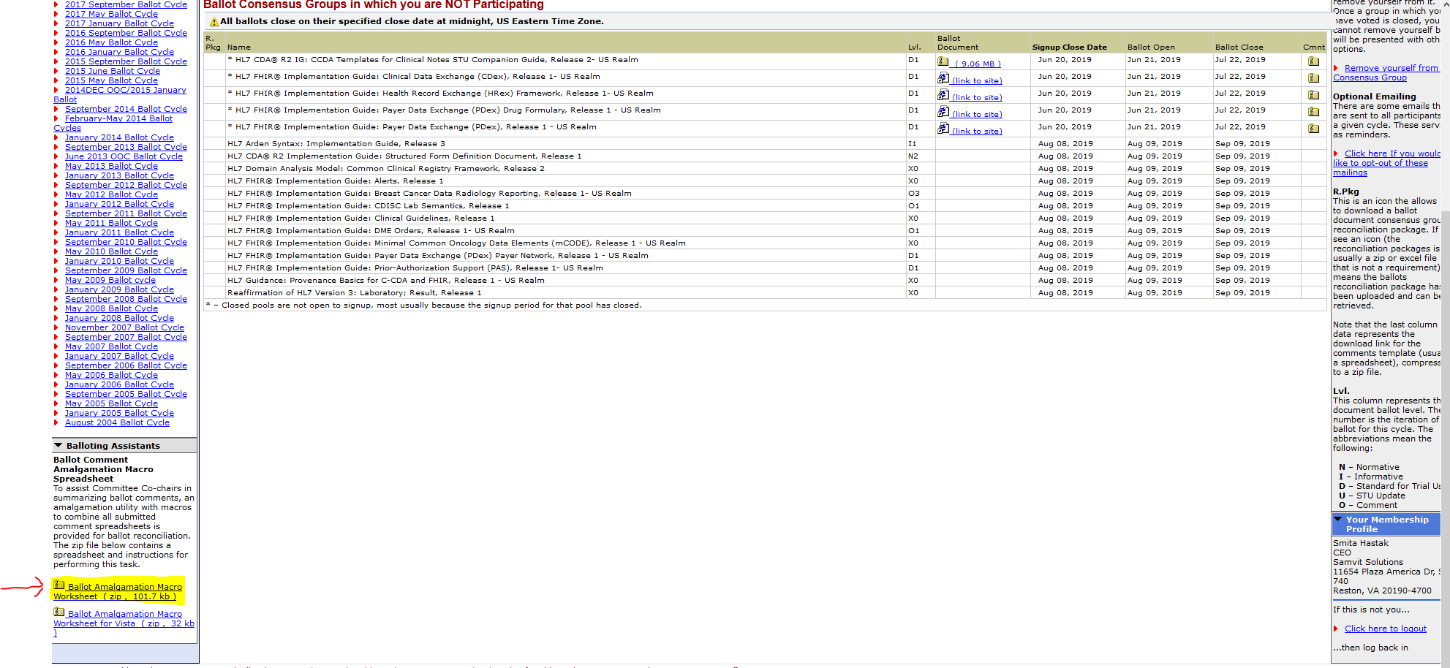

1. Run the amalgamation process.
   1. Open the amalgamation macro file in Excel and follow the instructions on the worksheet that are displayed when you open the file.
   2. Choose the Co-Chair radio button (rather than the Submitter button). Even though you probably aren’t a co-chair, you are acting as one to consolidate the comments.

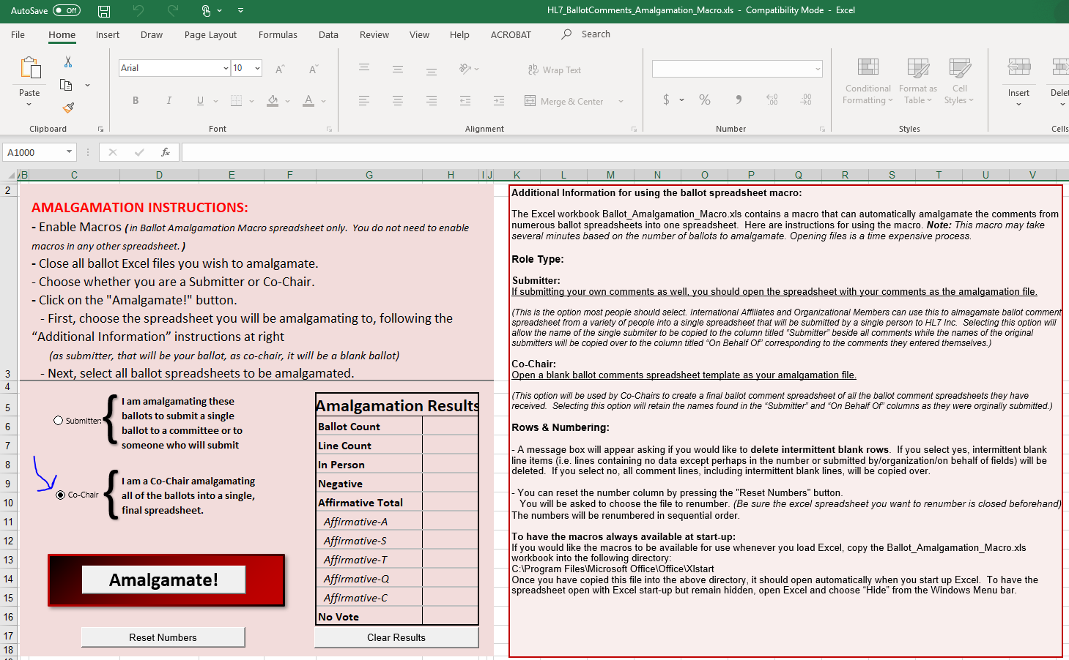

* 1. Click on the **Amalgamate!** button to start the consolidation process.
     1. Select the file to contain all the consolidated comments (the one that you downloaded in step 5 above).
     2. Select the file(s) that you want to consolidate (the ones that you downloaded in step 4c above).
     3. Answer yes to the “**Import Website Comments?**” question if there is a csv file in the BRIDG Ballot Results zip file (see step 4c above). The csv file contains all comments entered via the web-based interface.

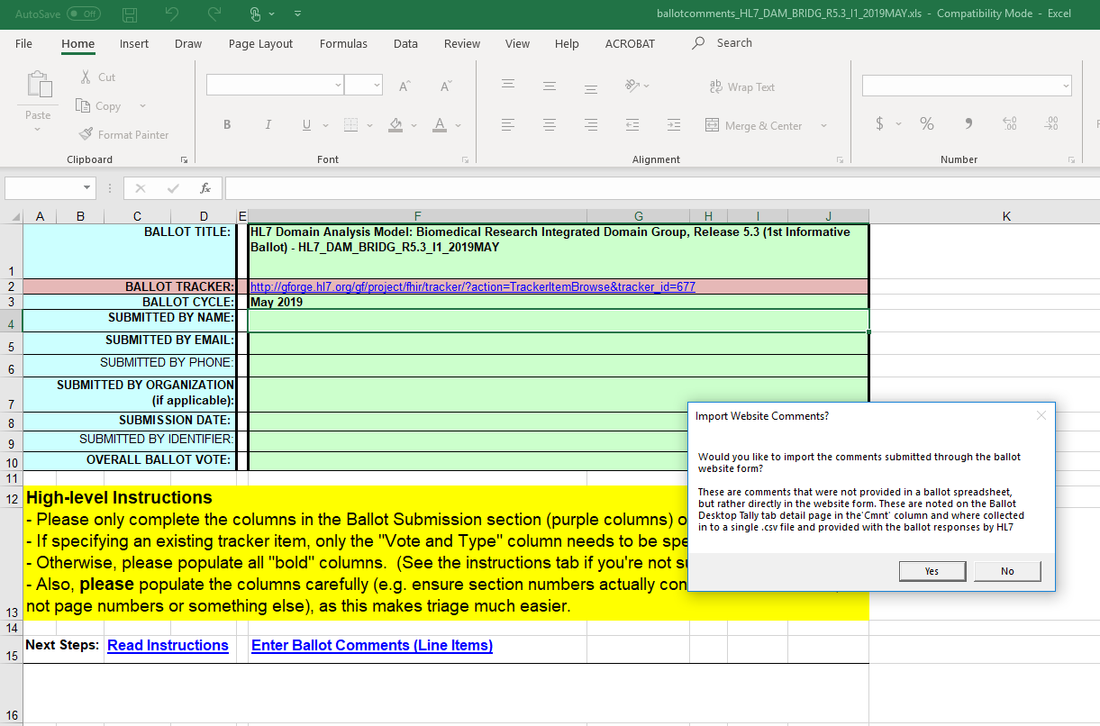

* 1. The macro will provide status info as it creates the consolidated file. When it finishes processing, it should look like the following screen shot. It should provide the amalgamation results (blue circle on the left) and indicate how many ballots were processed (blue circle on the right).

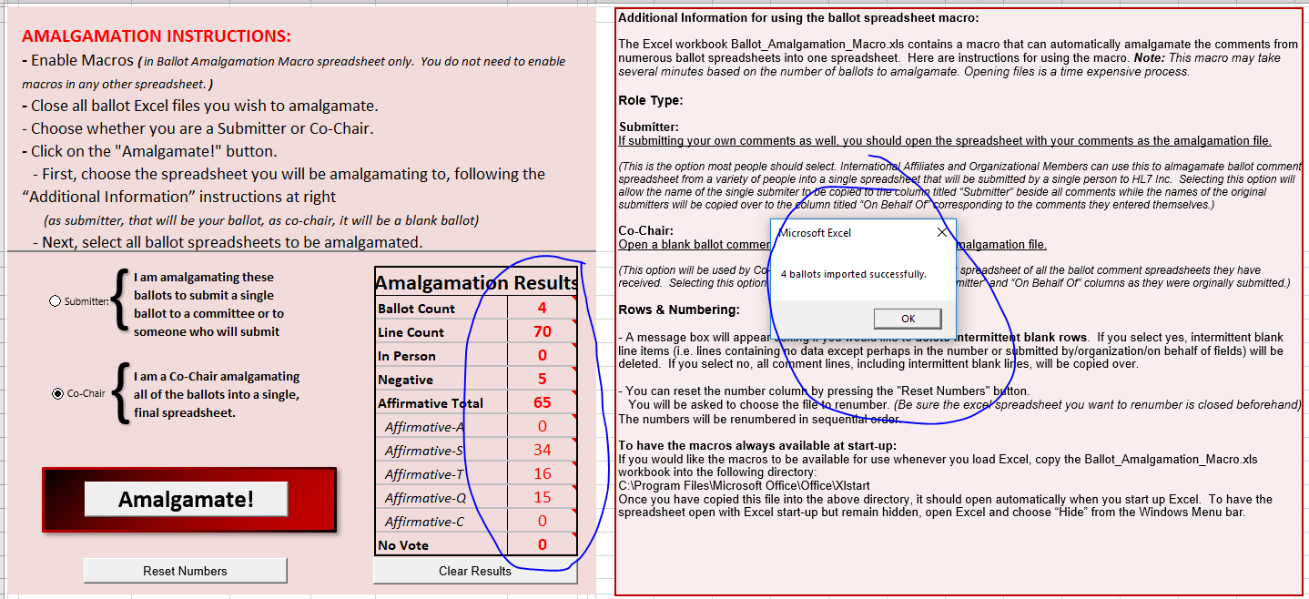

* 1. The consolidated spreadsheet will now contain all comments from the uploaded comment spreadsheets and the web-based interface. The web-based comments are noted in the Summary column as shown in the red circle in the screen shot below:

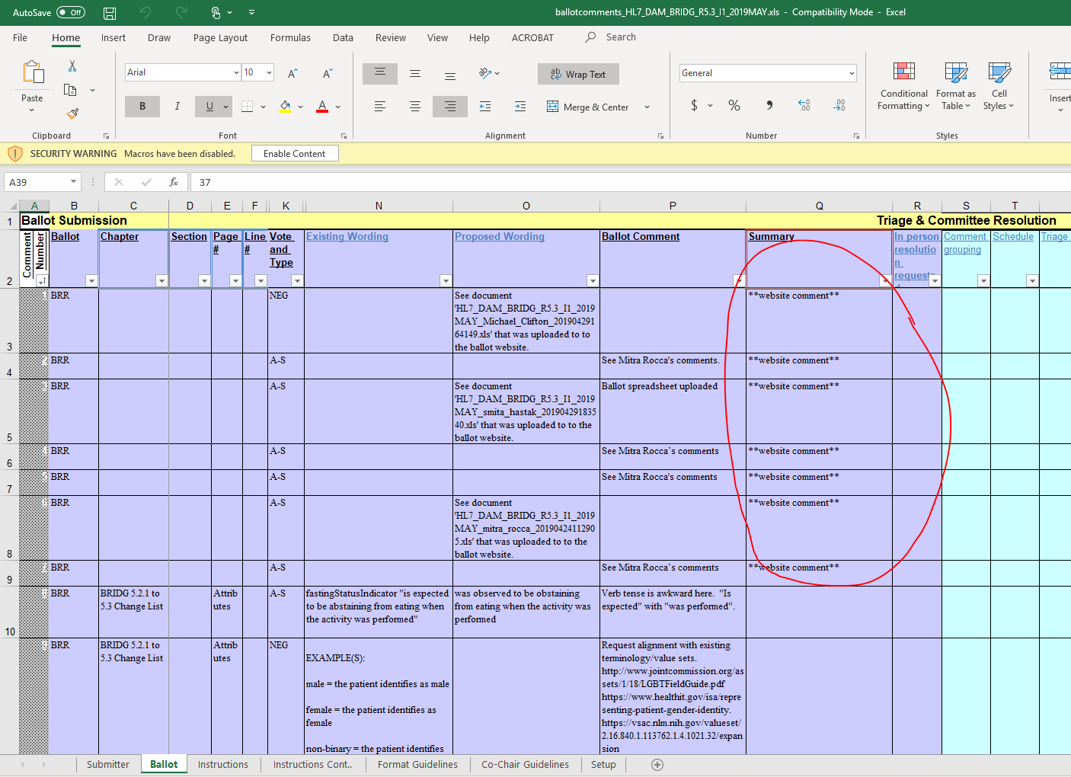

1. The ballot comment consolidation process is now complete!